PCB Threat Modeling
For this threat model, we consider a small IoT style PCB that includes a microcontroller (MCU), external SPI flash, a crypto/authentication chip, power and clock circuits, debug interfaces, and communication ports. These components introduce several potential attack surfaces, both during manufacturing and during field operation. Because modern PCBs rely on globally distributed supply chains, adversaries may attempt to insert hardware Trojans, tap sensitive traces, or manipulate power and clock behavior to compromise the system.
Threat Model Diagram
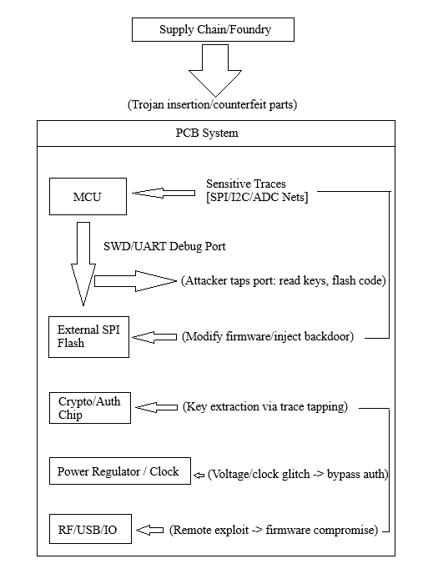
Figure 1
Key Attack Surfaces
The PCB presents several points where an attacker could attempt to compromise confidentiality, integrity, or availability:
- Sensitive Data Traces
  - SPI, I²C, ADC, or other communication nets carrying sensor data or cryptographic material.
  - Attackers may tap these traces to leak information or inject malicious signals.
- Debug Interfaces
  - SWD, UART, JTAG headers are often the highest value targets.
  - A malicious actor could basically read secret keys, extract firmware, flash modified code, and disable security features.
- External Memory (SPI Flash)
  - Firmware can be modified during manufacturing or through physical access.
  - A “trojanized” image could introduce hidden backdoors or change system behavior.
- Power and Clock Circuits
  - Fault injection through voltage or clock manipulation can bypass authentication or alter control flow.
  - These attacks require only brief access and minimal hardware.
- Communication Interfaces (RF/USB/UART)
  - Exposed ports may contain software vulnerabilities.
  - Remote adversaries can exploit protocol weaknesses or corrupt firmware updates.
Potential Threats
Using the attack surfaces above, an adversary could attempt:
- Data exfiltration: tapping sensitive nets or using radio interfaces to capture confidential data.
- Bypassing authentication: fault injection or firmware modification to skip security checks.
- Injecting malicious behavior: implanting an always on or trigger based hardware Trojan.
- Persistent compromise: altering external flash or debug settings to maintain long-term control.
Summary
The threat model highlights how a seemingly simple PCB can be exposed to multiple vectors, both physical and supply chain based. Sensitive traces, debug headers, external memory, and power manipulation represent high risk entry points that attackers can exploit if proper protections are not in place. Because security must be considered from fabrication to field deployment, combining design time safeguards with runtime protections is essential for reducing PCB level risks.

